|  |  |
| --- | --- |
| **Course signature** | TesterRemoteSK4 |
| **Team members names and surnames** | Zuzana Straková |
| **Project title** | Final Project |
| **Link to repository** | [GitHub](https://github.com/ZanaStrakova/Zuzana-Strakova-FINAL-PROJECT.git) |
| **Enviroment** | OS Windows 10 (64 -bit)  Firefox Mozilla Verzia 114.0.1 (64 - bit) |
| **Project description** (with listed, used technologies, testing plan) | For the final project I tested the website <https://www.andreashop.sk/>  My final project involves creating a test plan, writing test cases, functional testing of webside, preparing bug reports and final reports.  The first task was to write test cases by requirements-based testing and scenario-based testing in QACoverage.  The second task was to found minimum **3 bugs** by Exploratory Testing and to report them in Jira.  The User Stories were analyzed and I created the structure of the project based on Epic, Version, Test Cycle and Test Suites.  I created **12 Test Cases**, which were classified in folders and subfolders (based on requirements). I executed the test cases and I set up the status per step (passed/failed/blocked).  The bugs encountered were linked to the test cases and I established the severity for each one. I added outcomes: test executions, screenshots and comments.  To conclude the project I created a report (based on **4 graphic evaluations**) which describes the entire project.  You will find bellow the conclusion report. |

**FINAL PROJECT**

1. TEST CASE: **„Incorrect informations during registration“**

PRIORITY: high /vysoká/

PASS/FAIL/BLOCKED: **Pass**

**ACTUAL RESULT:**

**The system correctly identified the inaccuracy of the information.**

Pri registrácii som sa zamerala na registračný údaj v mieste zadania emailu ako nového užívateľa. Po zadaní jedného písmenka – „a“ a vyplnení zvyšných údajov a následnom stlačení tlačidla – Registrovať, systém vyhodnotil správne, že email je neplatný a teda nepovolil registráciu.

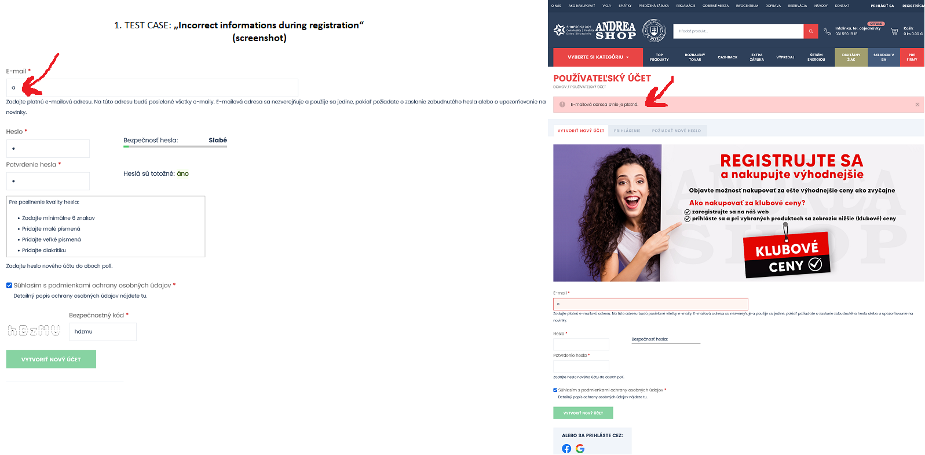

1. TEST CASE: **„Creating a weak password“**

PRIORITY: critical /kritická/

PASS/FAIL/BLOCKED: **Fail**

**ACTUAL RESULT:**

**The system indicates that the password is weak, but regardless, it proceeds with the creation of a new user registration.**

Počas vytvárania novej registrácie ako užívateľa, som sa zamerala na vytvorenie hesla a zámerne zvolila slabé heslo obsahujúce len jeden znak – „1“. Po vyplnení zvyšných údajov ma síce systém v okne hesla systém upozornil, že je to slabé heslo, ale registroval ma a vpustil na stránku už ako prihláseného nového užívateľa.

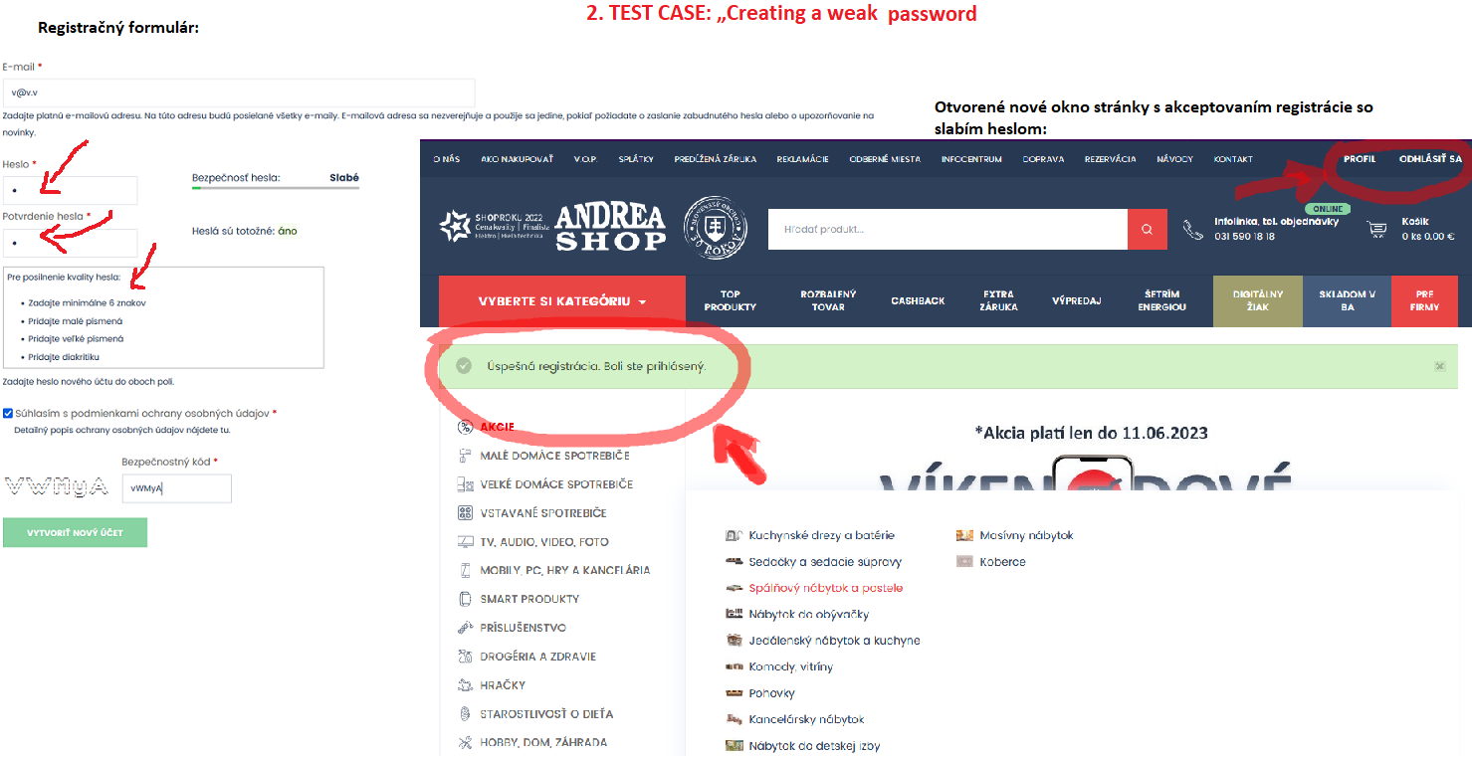

1. TEST CASE: **„Registration - not revealed password“**

PRIORITY: medium /stredná/

PASS/FAIL/BLOCKED: **Blocked**

**ACTUAL RESULT:**

**The password cannot be revealed while typing. There is missing button to uncoverage the hidden text.**

Na stránke chýba počas vypĺňania registračného formulára pre nového užívateľa možnosť odkrytia hesla.

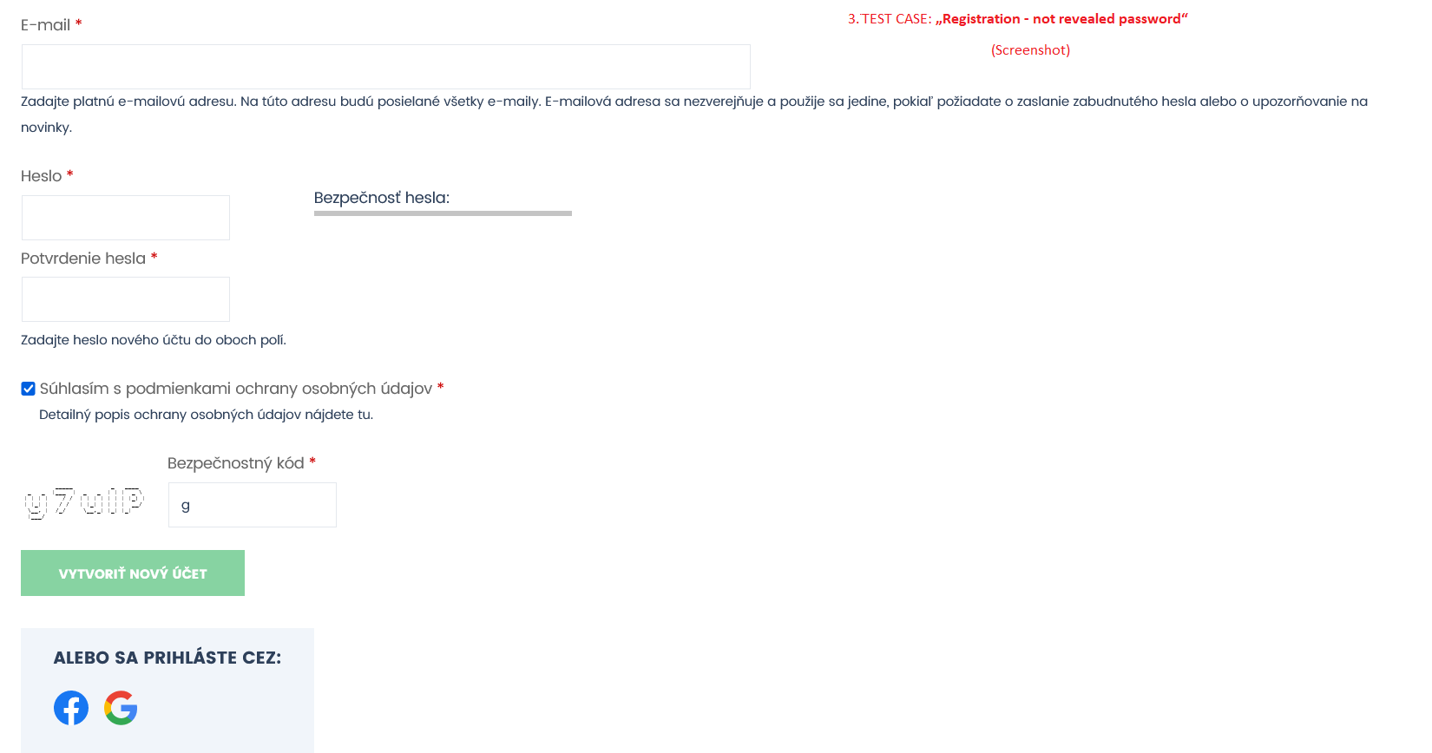

1. TEST CASE: **„Verification email is missing“**

PRIORITY: medium /stredná/

PASS/FAIL/BLOCKED: **Fail**

**ACTUAL RESULT:**

**Despite entering a non-existent email, the system creates a registration and allows me to access the page as a logged-in user without sending a verification email.**

Systém počas vyplnenia údajov registrácie nového užívateľa a načítania stránky už ako nového užívateľa nevyhodnotil, že email nie je validný a po registrácii nevyžadoval verifikáciu konkrétneho emailu.

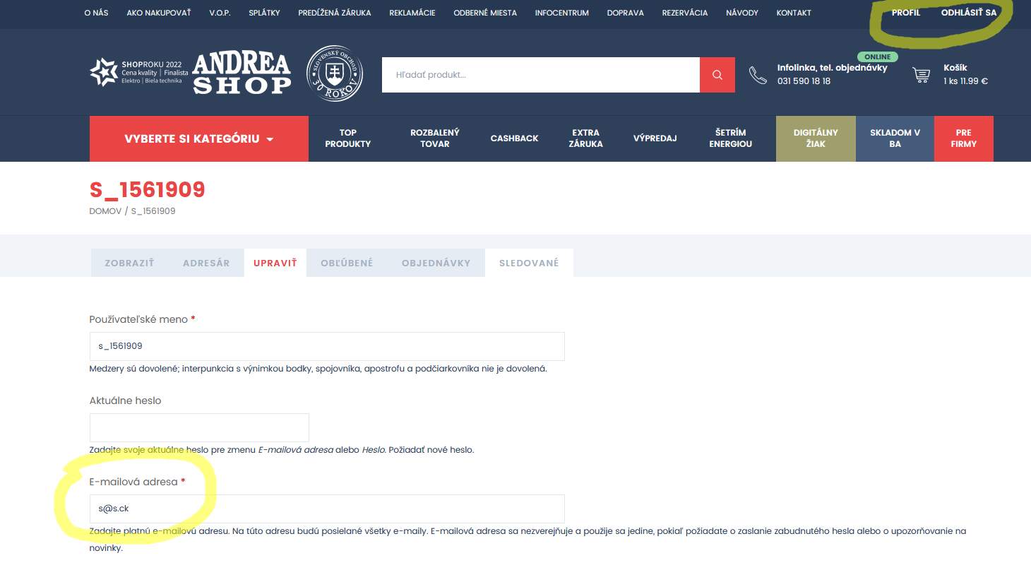

1. TEST CASE: **„Payment - Wrong billing details“**

PRIORITY: high /vysoká/

PASS/FAIL/BLOCKED: **Fail**

**ACTUAL RESULT:**

**The system correctly assessed that the information is not accurate, and therefore, it will not load the next step**, **but not immediately  during filling out the form.**

Systém počas vyplnenia údajov fakturačného formulára síce vygeneruje mesto podľa PSČ, no ak ho nenavolím a napíšem nesprávne, nereaguje automaticky vyznačením políčka ako chybného, ale až po potvrdení všetkých políčok a kliknutím na pokračovanie k platbe, vyskočí informačné okno. Ako e-shop zameraný na predaj produktov, by som zvážila možnosť vyššej kontroly systému korektnosti informácií.

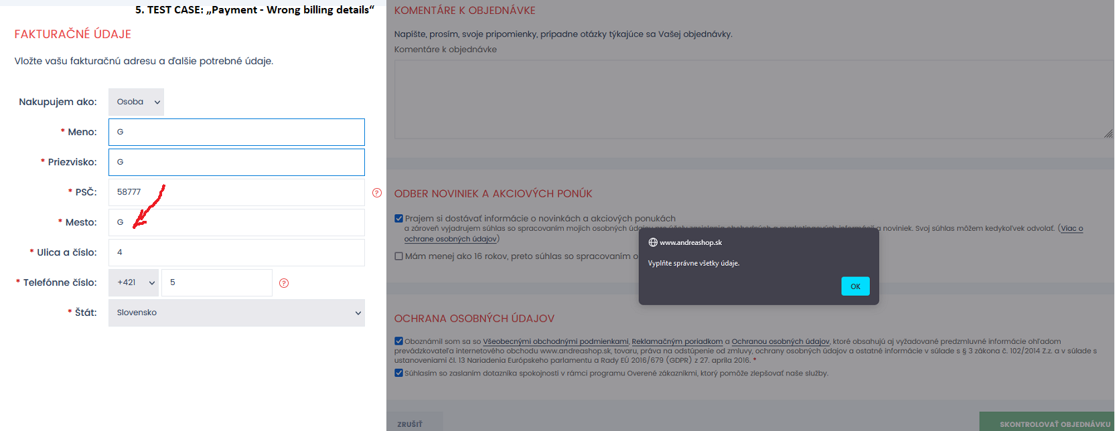

1. TEST CASE: **„Adding item to the basket“**

PRIORITY: critical /kritická/

PASS/FAIL/BLOCKED: **Pass**

**ACTUAL RESULT:**

**Adding product to the basked is valid.**

Pridanie produktu do košíka je validné.

1. TEST CASE: **„Deleting product from the basket“**

PRIORITY: critical /kritická/

PASS/FAIL/BLOCKED: **Pass**

**ACTUAL RESULT:**

**Deleting product from the basked is valid.**

Vymazanie produktu z košíka je validné.

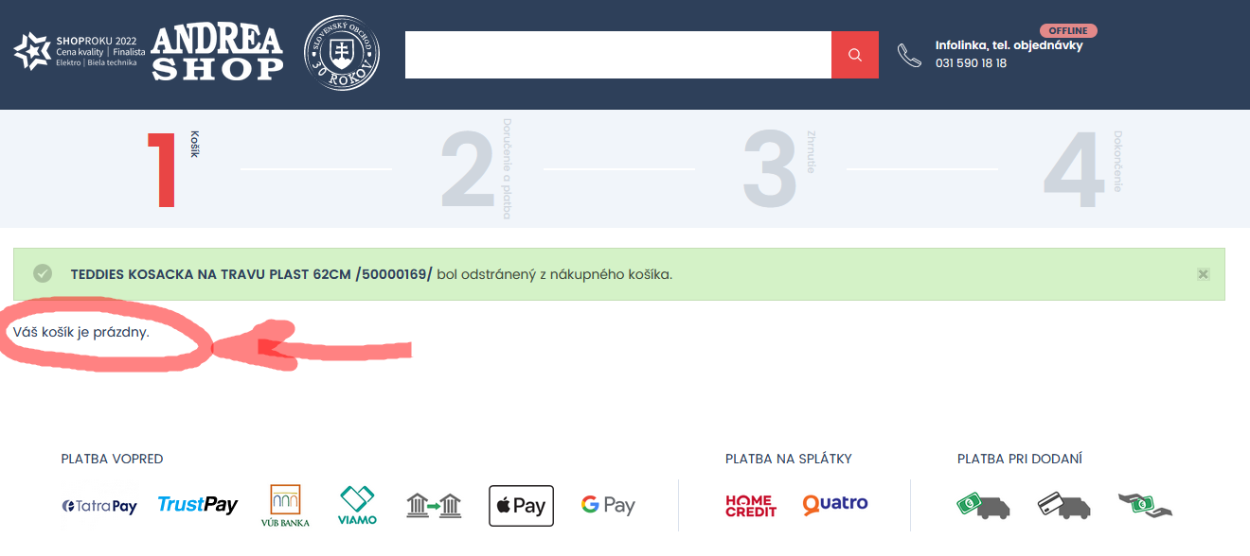

1. TEST CASE: **„Items price - from the most expensive“**

PRIORITY: low /nízka /

PASS/FAIL/BLOCKED: **Pass**

**ACTUAL RESULT:**

**The filter of the products is valid. The products are sorted in descending order by highest price.**

Filtrovací systém produktov správne zoradil ceny od najvyšších.

1. TEST CASE: **„Items price - from the cheapest products“**

PRIORITY: low /nízka/

PASS/FAIL/BLOCKED: **Pass**

**ACTUAL RESULT:**

**The filter of the products is valid. The products are sorted by cheapest price.**

Filtrovací systém produktov správne zoradil ceny od najnižších.

1. TEST CASE: **„Gift for purchases over 300 euros“**

PRIORITY: critical /kritická/

PASS/FAIL/BLOCKED: **Pass**

**ACTUAL RESULT:**

**The gift for items over 300 euros is valid.**

Darček sa zobrazil v košíku pri produkte so sumou nad 300 eur.

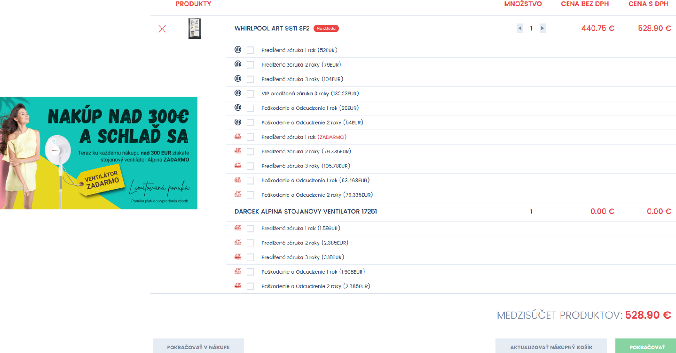

1. TEST CASE: **„Valid discount code 30%“**

PRIORITY: critical / kritická /

PASS/FAIL/BLOCKED: **Pass**

**ACTUAL RESULT:**

**The discount code 30% is valid.**

Systém vyhodnotil správne, že produkt vložený do košíka patrí medzi vybrané produkty na 30% zľavu a preto udelil zľavu 30%.

1. TEST CASE: **„Invalid discount code 30%“**

PRIORITY: critical / kritická /

PASS/FAIL/BLOCKED: **Pass**

**ACTUAL RESULT:**

**The system evaluated that the product does not belong to the selected products for a 30% discount and did not apply the discount code.**

Systém vyhodnotil správne, že produkt vložený do košíka nepatrí medzi vybrané produkty na 30% zľavu a preto neudelil zľavu 30%.

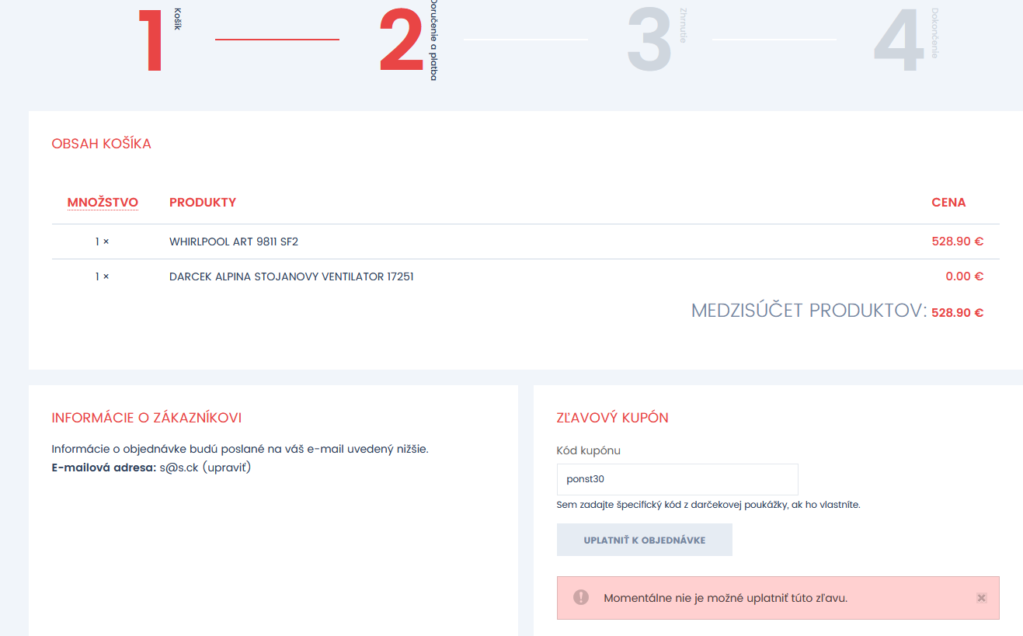

**Graphic evaluation /Grafické vyhodnotenie**

1. **Registration - all test cases as a new user by QACoverage**

(Všetky testovacie prípady registrácie ako nového užívateľa.)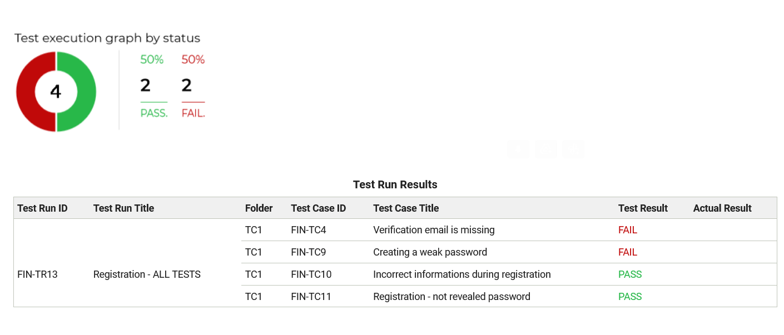

1. **Payment and basket – all test cases by QACoverage**

(Všetky testovacie prípady platby a nákupného košíka.)

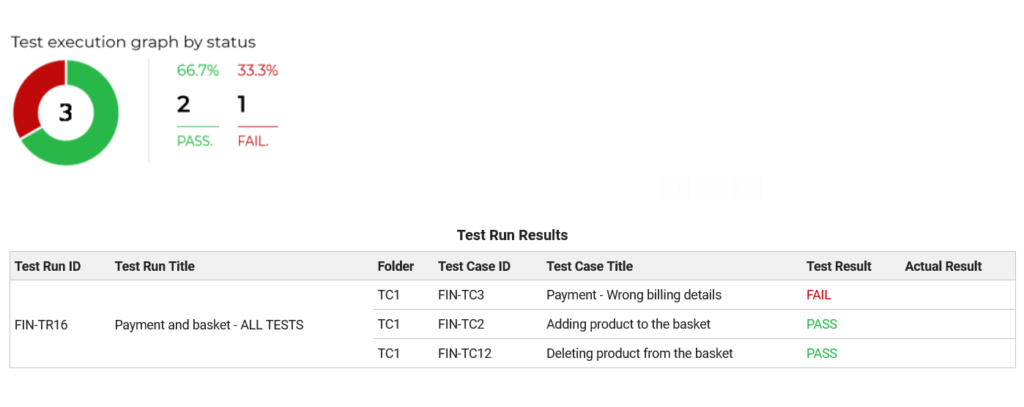

1. **Special price – all test cases by QACoverage**

(Špeciálne ceny produktov – všetky testovacie prípady)



1. **Andrea shop – All test cases by QACoverage**

(Všetky testovacie prípady Andrea shop)

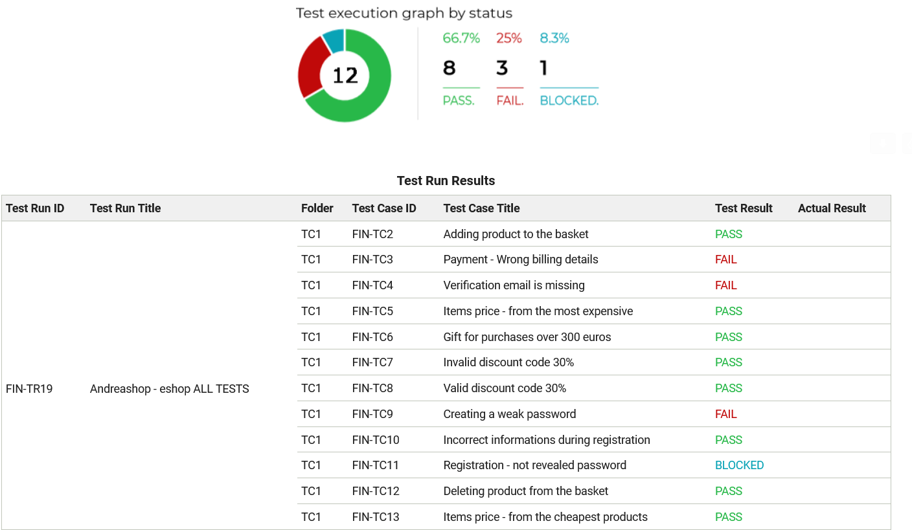

**Bug reports in JIRA:**

|  |  |
| --- | --- |
| [TEST-1] [Verification email is missing](https://zzanastrakova.atlassian.net/browse/TEST-1) Created: 12/Jun/23  Updated: 12/Jun/23 | |
| **Status:** | To Do |
| **Project:** | [TEST](https://zzanastrakova.atlassian.net/secure/BrowseProject.jspa?id=10000) |
| **Components:** | None |
| **Affects versions:** | None |
| **Fix versions:** | None |

|  |  |  |  |
| --- | --- | --- | --- |
| **Type:** | Bug | **Priority:** | Medium |
| **Reporter:** | [Zuzzana Straková](https://zzanastrakova.atlassian.net/secure/ViewProfile.jspa?accountId=63f9111cc1f7acaf636d07df) | **Assignee:** | [Zuzzana Straková](https://zzanastrakova.atlassian.net/secure/ViewProfile.jspa?accountId=63f9111cc1f7acaf636d07df) |
| **Resolution:** | Unresolved | **Votes:** | 0 |
| **Labels:** | None | | |
| **Remaining Estimate:** | Not Specified | | |
| **Time Spent:** | Not Specified | | |
| **Original estimate:** | Not Specified | | |

|  |  |
| --- | --- |
| **Attachments:** | registr a zlý mail(1).png |
| **Rank:** | 0|hzzzzz: |
| **Sprint:** | TEST Sprint 1 |
| **Story point estimate:** | 0 |

|  |  |
| --- | --- |
| **Description** |  |

|  |
| --- |
| **Enviroment:**  OS Windows - 10 (64bit)  Mozilla Firefox - 114.0.1 (64-bit)  **Steps to reproduce:**   1. Click on <https://www.andreashop.sk/> 2. Click on “Registrácia”. 3. Insert non valid email to the empty email field . 4. In email field is text [**"s@s.ck**](mailto:%22s@s.ck)**".** 5. Insert password - “gg99Cg” into password input. 6. Insert same password into password confirmation input - “gg99Cg”. 7. Click  and check the checkbox for consent. 8. Enter the actual security code into the empty security code field. 9. Click on the button - “Vytvoriť nový účet”. 10. New account is created.   **Expected results:**  After filling out the registration form, the system will send a verification email for verification purposes.  (Systém po vyplnení registračného formulára zašle verifikačný email na jeho overenie.)  **Actual results:**  **Despite entering a non-existent email, the system creates a registration and allows me to access the page as a logged-in user without sending a verification email.**  (Systém počas registrácie nového užívateľa nevyhodnotil správne, že email je neexistujúci a po registrácii nevyžaduje verifikáciu mailom) |

Generated at Mon Jun 12 15:46:51 UTC 2023 by Zuzzana Straková using Jira 1001.0.0-SNAPSHOT#100225-sha1:956085dc1481faa784d93909f621779bd3cfa13c.

|  |  |
| --- | --- |
| [TEST-2] [Creating a weak password](https://zzanastrakova.atlassian.net/browse/TEST-2) Created: 12/Jun/23  Updated: 12/Jun/23 | |
| **Status:** | In Progress |
| **Project:** | [TEST](https://zzanastrakova.atlassian.net/secure/BrowseProject.jspa?id=10000) |
| **Components:** | None |
| **Affects versions:** | None |
| **Fix versions:** | None |

|  |  |  |  |
| --- | --- | --- | --- |
| **Type:** | Bug | **Priority:** | Critical |
| **Reporter:** | [Zuzzana Straková](https://zzanastrakova.atlassian.net/secure/ViewProfile.jspa?accountId=63f9111cc1f7acaf636d07df) | **Assignee:** | Unassigned |
| **Resolution:** | Unresolved | **Votes:** | 0 |
| **Labels:** | None | | |
| **Remaining Estimate:** | Not Specified | | |
| **Time Spent:** | Not Specified | | |
| **Original estimate:** | Not Specified | | |

|  |  |
| --- | --- |
| **Attachments:** | Screenshot_1.png     registr.png |
| **Rank:** | 0|i00007: |
| **Sprint:** |  |

|  |  |
| --- | --- |
| **Description** |  |

|  |
| --- |
| **Enviroment:**  OS Windows - 10 (64bit)  Mozilla Firefox - 114.0.1 (64-bit)  **Steps to reproduce:**   1. Click on <https://www.andreashop.sk/> 2. Click on “Registrácia”. 3. Insert non valid email to the empty email field . 4. In email field is text **"v@v.v“.** 5. Insert password - “1” into password input. 6. Insert same password into password confirmation input - “1”. 7. Click  and check the checkbox for consent. 8. Enter the actual security code into the empty security code field. 9. Click on the button - “Vytvoriť nový účet”. 10. New account is created.   **Expected results:**  The system recognizes weak passwords and will not create a registration for a new user.  (Systém rozpozná slabé heslo a nevytvorí registráciu nového užívateľa.)  **Actual results:**  **"The system indicates that the password is weak, but regardless, it proceeds with the creation of a new user registration.**  (Systém oznamuje, že heslo je slabé, ale napriek tomu vytvorí registráciu nového užívateľa.) |

Generated at Mon Jun 12 15:56:41 UTC 2023 by Zuzzana Straková using Jira 1001.0.0-SNAPSHOT#100225-sha1:956085dc1481faa784d93909f621779bd3cfa13c.

|  |  |
| --- | --- |
| [TEST-3] [Payment - Wrong billing details](https://zzanastrakova.atlassian.net/browse/TEST-3) Created: 12/Jun/23  Updated: 12/Jun/23 | |
| **Status:** | To Do |
| **Project:** | [TEST](https://zzanastrakova.atlassian.net/secure/BrowseProject.jspa?id=10000) |
| **Components:** | None |
| **Affects versions:** | None |
| **Fix versions:** | None |

|  |  |  |  |
| --- | --- | --- | --- |
| **Type:** | Bug | **Priority:** | High |
| **Reporter:** | [Zuzzana Straková](https://zzanastrakova.atlassian.net/secure/ViewProfile.jspa?accountId=63f9111cc1f7acaf636d07df) | **Assignee:** | [Zuzzana Straková](https://zzanastrakova.atlassian.net/secure/ViewProfile.jspa?accountId=63f9111cc1f7acaf636d07df) |
| **Resolution:** | Unresolved | **Votes:** | 0 |
| **Labels:** | None | | |
| **Remaining Estimate:** | Not Specified | | |
| **Time Spent:** | Not Specified | | |
| **Original estimate:** | Not Specified | | |

|  |  |
| --- | --- |
| **Attachments:** | fakturačné údaje 2.png     fakturačné údaje.png |
| **Rank:** | 0|i0000f: |
| **Sprint:** | TEST Sprint 1 |

|  |  |
| --- | --- |
| **Description** |  |

|  |
| --- |
| **Enviroment:**  OS Windows - 10 (64bit)  Mozilla Firefox - 114.0.1 (64-bit)  **Steps to reproduce:**   1. Click on <https://www.andreashop.sk/teddies-kosacka-na-travu-plast-62cm-50000169> 2. Click on button “Do košíka”. 3. Klick on the basket icon. 4. Klick on the button “Pokračovať”. 5. Scroll down for the billing details. 6. Insert **non existing name** to empty field = “G”. 7. Insert **non existing surname** to empty field surname = “G” 8. Insert nummber to empty field named zipcode -58777. 9. Insert **non existing name** **of the city** to empty field - the city = “G”. 10. Insert city to empty field - street and number = “4”. 11. Insert **non valid** numbers to empty field - telephone number = “4” 12. Choose the State = Slovensko. 13. Choose payment method = the first and second chcekbox is picked. 14. Do not confirm the checkboxes of “Information and news” and “Less then 16 years personal data protection”. 15. Check the both boxes of Data protection. 16. Klick on button - "Skontrolovať objednávku"   **Expected results:**  During the filling out of the payment form with personal data, the system immediately evaluates any incorrect information entered.  (Systém počas vyplňovania platobného formulára osobných údajov, vyhodnotí ihneď zadané nekorektné informácie.)  **Actual results:**  **The system correctly assessed that the information is not accurate, and therefore, it will not load the next step, but not immediately  during filling out the form.**  (Systém počas vyplňovania platobného formulára osobných údajov, nevyhodnotil zadané nekorektné informácie ihneď, ale až po potvrdení celého procesu.) |

Generated at Mon Jun 12 16:14:51 UTC 2023 by Zuzzana Straková using Jira 1001.0.0-SNAPSHOT#100225-sha1:956085dc1481faa784d93909f621779bd3cfa13c.